**CAPSTONE PROJECT**

**MADARASI- A TRAVELOGUE WEBSITE TO EXPLORE**

**THE PLACES OF CHENNAI**

**A PROJECT REPORT**

***Submitted by***

HARISH V [192211049]

DHANUSH V A [192211274]

GIRI PRASATH B [192211302]

*Under the guidance of*

# Mr. S. YUVARAJ

***in partial fulfillment for the completion of course CSA4301- INTERNET***

***PROGRAMMING FOR SERVER-SIDE APPLICATIONS***

**SIMATS ENGINEERING**

**THANDALAM**



**SEPTEMBER 2024**

## DECLARATION

We, **Harish V, Dhanush V A**, **Giri Prasath B,** students of **Bachelor of Engineering in Computer Science**, Department of Computer Science and Engineering, Saveetha Institute of Medical and Technical Sciences, Saveetha University, Chennai, hereby declare that the work presented in this Capstone Project Work entitled **“MADARASI- A TRAVELOGUE WEBSITE TO EXPLORE THE PLACES OF CHENNAI”** is the outcome of our own bonafide work and is correct to the best of our knowledge and this work has been undertaken taking care of Engineering Ethics.

**Harish V(192211049) Dhanush V A(192211274) Giri Prasath B (192211302)**

### BONAFIDECERTIFICATE

Certified that this project report titled **“MADARASI- A TRAVELOGUE WEBSITE TO**

#### EXPLORE THE PLACES OF CHENNAI” is the bonafide work of “HARISH V

**[192211049], DHANUSH V A [192211272], GIRIPRASATH B [192211302]”** Students of **Bachelor of Engineering in Computer Science,** Saveetha institute of Medical and Technical Sciences, Chennai, who carried out the project work under my supervision as a batch. Certified further, that to the best of my knowledge the work reported herein does not form any other project report .

**Date : Project supervisor Head of the Department**

**TABLE OF CONTENTS**

|  |  |
| --- | --- |
| **S.NO** | **TOPICS** |
| **1.** | **Introduction** |
| **2.** | **Abstract** |
| **3.** | **Problem Description**  Program to Build a simple software for Madarsi |
| **4.** | **Materials and Methods**  User Interface  Features |
| **5.** | **Approach/Module Description/Functionalities** |
| **6.** | **Implementation** Coding |
| **7.** | **Output** |
| **8.** | **Conclusion**  Future Enhancement  **References** |

#### INTRODUCTION

In the digital age, travel blogging has emerged as a vibrant way for enthusiasts to share their personal journeys, experiences, and insights with a global audience. The rise of travel blogs has not only inspired people to explore new destinations but has also created communities centered around the shared passion for adventure, discovery, and cultural exchange. This project focuses on creating a visually captivating and user-friendly travel blog website that serves as a comprehensive platform for a travel enthusiast to document and share their adventures. The blog aims to connect with a broad audience by providing rich, immersive content that includes stunning visuals, detailed narratives, and practical travel tips.

The homepage of the website is designed to instantly capture the visitor's attention with a blend of breathtaking travel photos and an interactive map showcasing the destinations visited by the blogger. This visual approach helps create an immediate sense of wanderlust and curiosity, encouraging users to explore more content on the site. Each blog post is crafted to provide an in-depth experience, combining engaging storytelling with high-quality images that reflect the unique charm of each location. These posts are categorized into sections such as destinations, travel guides, food experiences, and cultural insights, enabling readers to easily navigate and find content that aligns with their interests.

A key feature of the website is its interactive elements that foster engagement and build a community of like-minded travelers. The inclusion of a comment section allows readers to share their thoughts, ask questions, and connect directly with the blogger, creating a space for dialogue and exchange of ideas. This interactive aspect enhances the user experience, making the blog not just a source of information but also a platform for connection and conversation.

Additionally, the website features an "About" page that provides insights into the blogger's journey, motivations, and passion for travel. This personal touch helps build a deeper connection with the audience, making the blog feel more relatable and authentic. The "Resources" section is designed to provide value to fellow travelers by offering useful tools such as packing lists, travel itineraries, budget tips, and booking recommendations. This curated collection of resources serves as a one-stop guide for anyone planning their next adventure, enhancing the website's utility and appeal.

To further extend the blog's reach and engagement, social media integration is incorporated into the platform. Readers can easily share their favorite posts across various social media channels, helping to spread the content organically and attract new visitors to the site. The integration also allows readers to follow the blogger’s adventures in real-time, creating a more connected and interactive experience.

#### ABSTRACT

This project involves the development of a dynamic travel blog website designed to showcase a travel enthusiast's adventures and experiences to a global audience. The website's homepage features an engaging and visually appealing layout, highlighted by stunning travel photos and an interactive map pinpointing the blogger's visited destinations.

Each blog post provides an immersive storytelling experience, enriched with detailed narratives, captivating images, and practical travel tips, categorized into sections such as destinations, travel guides, food experiences, and cultural insights. The platform encourages reader interaction through a comment section where users can share their thoughts, ask questions, and engage with the blogger.

An "About" page offers insights into the blogger's journey and passion for travel, while a "Resources" section provides valuable tools, such as packing lists and booking recommendations, to assist fellow travelers. Social media integration enables seamless sharing of content and allows readers to follow the blogger’s real-time adventures.

This website aims to inspire and inform travel enthusiasts while fostering a sense of community among global travelers.

**AIM:** To design and implement the Travel web application to explore the places of Chennai.

**MATERIALS REQUIRED:** Hypertext Markup Language (HTML), Cascading Styles Sheet (CSS), Java Script (js), and developing environment like Visual Studio code is required.

**VS Code:** Visual Studio Code (VS Code) is a free, open-source code editor developed by Microsoft, designed to be lightweight yet powerful. It supports numerous programming languages and offers features such as syntax highlighting, integrated Git version control, and advanced debugging tools.

With its extensive marketplace, users can enhance functionality through a wide range of extensions and customize their development environment to fit their needs. VS Code also includes a built-in terminal and supports real-time collaboration through the Live Share extension, making it a versatile tool for developers.

#### TRAVELOGUE

Chennai, the bustling capital of Tamil Nadu, is a city where tradition and modernity blend seamlessly. From the moment you arrive, you are greeted by the vibrant colors and the rhythmic sounds of South Indian culture. The city’s iconic Marina Beach stretches along the Bay of Bengal, offering a perfect spot for a leisurely stroll while enjoying the cool sea breeze. The lively atmosphere of the beach is complemented by local vendors selling everything from spicy sundal to refreshing tender coconut water. Just a short distance away, you’ll find the historic Fort St. George, a testament to Chennai’s colonial past, and the beautiful Kapaleeshwarar Temple, which showcases intricate Dravidian architecture and vibrant temple rituals.

Venturing into the heart of Chennai reveals a tapestry of experiences. The bustling streets of T. Nagar, famous for its shopping and traditional jewelry, contrast sharply with the serene ambiance of the city’s numerous temples and parks. The Chennai Museum offers a glimpse into the rich heritage of the region with its diverse collection of artifacts and art. For food enthusiasts, the city’s culinary scene is a treasure trove of flavors, from aromatic dosas and idlis to spicy Chettinad curries. As the day ends, the city lights up with a blend of modern cafes and traditional eateries, offering a taste of both contemporary and classic Chennai. Whether you're exploring historic landmarks or indulging in local delicacies, Chennai presents an engaging and memorable experience.

#### METHODOLOGY

For the development of the frontend of a web application focused on Chennai tourism guidance and hotel booking reviews, **Visual Studio Code (VS Code)** is used as the primary code editor. The web pages are structured using **HTML** to create the content layout, such as sections for tourist attractions, hotel listings, and user reviews. **CSS** is employed to style the site, providing a visually appealing design, while **Bootstrap** ensures the layout is responsive and adjusts well across various screen sizes and devices, making it mobile-friendly.

**JavaScript** is integrated for client-side interactivity, enabling dynamic features such as dropdown menus, form validation for hotel reviews, and interactive maps for tourist locations. Additionally, JavaScript allows the website to handle basic functionality like filtering and sorting hotel listings based on user preferences. The combination of these technologies offers a seamless user experience for exploring Chennai's tourist attractions and browsing hotel reviews, all within a well-designed, interactive frontend.

The frontend development also incorporates **responsive design principles**, ensuring that the website adapts seamlessly across different devices, including desktops, tablets, and smartphones. **Google Fonts** and **Font Awesome** are used to enhance typography and iconography, giving the site a modern and visually appealing look. For better user navigation, elements like navigation bars, carousels for hotel images, and interactive maps are implemented.

#### IMPLEMENTATION

The implementation of the Chennai tourism guidance and hotel booking reviews website begins with designing the overall layout using HTML. The site is structured into key sections, including a homepage featuring popular tourist destinations, a dedicated page for hotel listings, and a review section for user-generated feedback. CSS and Bootstrap are utilized to style the pages and ensure they are responsive, with elements such as navigation bars, image carousels, and grid layouts for displaying hotel information effectively on both desktop and mobile devices. The user interface is designed to be intuitive, allowing users to easily explore tourist spots and read reviews.

To enhance interactivity, JavaScript is implemented for various dynamic elements, such as filtering hotel listings based on ratings, sorting by price, and enabling real-time search functionality. Event listeners are added to buttons and input fields to allow smooth user interactions, such as submitting hotel reviews or navigating through different sections of the site. Additionally, animations and transitions are incorporated using JavaScript to improve user experience, ensuring that the website is not only informative but also engaging. Through careful implementation of these features, the site provides an interactive and visually appealing platform for users to explore Chennai tourism options and review hotels.

In the implementation phase, the Bootstrap framework was heavily utilized to ensure that the website is responsive and adaptable to different screen sizes. Pre-built Bootstrap components, such as navigation bars, grid systems, and buttons, were customized to create a consistent and clean layout. Additionally, custom CSS was added to personalize the website's appearance, enhancing the design of elements like fonts, colors, and spacing to align with the Chennai tourism theme. The use of media queries ensured that content, such as hotel listings and tourist information, automatically adjusts and remains visually appealing on devices ranging from desktops to smartphones.

Furthermore, JavaScript was used to implement dynamic functionalities such as a real-time search bar and filtering options for hotel listings. By leveraging JavaScript’s event listeners and DOM manipulation techniques, the user experience was enhanced through smooth interactions, like the instant display of filtered results or a live preview of user-submitted reviews. This not only improved the interactivity of the website but also contributed to a faster and more intuitive user experience, with minimal page reloads. Overall, the integration of these tools and techniques resulted in a robust and responsive frontend for Chennai tourism guidance and hotel booking reviews.

#### USER INTERFACE DESCRIPTION

The user interface (UI) of the Chennai Tourism Guidance and Hotel Booking Reviews application is designed to be clean, intuitive, and user-friendly, with a focus on ease of navigation and visual appeal.

1. **Homepage**: The homepage serves as a central hub, featuring a **banner section** with high-quality images of Chennai's iconic tourist attractions. Below the banner, a **navigation bar** allows users to easily access other sections such as the **Tourist Spots**, **Hotel Listings**, and **Reviews** pages. The homepage also highlights featured tourist spots and recommended hotels, with clickable cards that lead to detailed pages for each attraction or accommodation.
2. **Navigation Bar**: The **navigation bar** is fixed at the top and includes links to major sections of the site like "Home," "Tourist Attractions," "Hotels," and "Submit a Review." This bar remains visible as users scroll down, ensuring quick access to other parts of the site. On mobile devices, a **hamburger menu** is used to save screen space while still providing easy access to all options.
3. **Tourist Spots Section**: The **Tourist Spots** page showcases a grid or list view of various tourist attractions in Chennai. Each attraction is displayed as a **clickable card** containing an image, brief description, and "Learn More" button. Clicking on a card takes users to a dedicated page with detailed information, photos, and an interactive map showing the location.
4. **Hotel Listings Page**: The **hotel listings** page is organized in a card-based layout with each hotel shown as a card containing an image carousel, a brief description, and essential details like price, rating, and location. **Filter and sort options** are positioned at the top, allowing users to refine the hotel list based on preferences like rating, price, or proximity to certain attractions. This ensures a smooth browsing experience.
5. **Review Submission Page**: The **review submission page** has a simple, user-friendly form where users can submit reviews of hotels. Input fields include text boxes for hotel name, rating (on a 5-star scale), and comments. A **submit button** at the end of the form processes the input and adds the review to the relevant hotel’s page.
6. **Interactive Map**: Integrated **interactive maps** allow users to visualize the location of hotels and tourist attractions. These maps are embedded on both the **Tourist Spots** and **Hotel Listings** pages, offering zoom and navigation functionality to help users understand distances and routes.
7. **Footer Section**: At the bottom of every page is a **footer** containing links to important sections like "Contact Us," "Privacy Policy," and "Terms of Service." Social media icons are also included, linking to relevant profiles.

#### MODULE DESCRIPTION

##### Home Module

The Home module serves as the landing page of the application, providing an overview of Chennai’s tourism highlights and hotel recommendations. This module contains a banner section with featured images of popular tourist destinations, welcoming users to explore more. Below the banner, there are featured sections displaying a curated list of top tourist attractions and recommended hotels, each presented in a card-based layout. The Home module is designed to provide a visually engaging introduction to the site’s content, with clickable elements that guide users to explore detailed pages for specific tourist spots and hotels.

##### Tourist Attractions Module

The Tourist Attractions module offers a comprehensive guide to Chennai's key tourist destinations. This module is organized in a grid layout, where each attraction is displayed with an image, brief description, and a link to a dedicated page. Each page provides detailed information, including historical significance, location, visiting hours, and an embedded interactive map to help users plan their visit. The module also allows users to filter and search for attractions based on categories like historical sites, cultural landmarks, or nature spots, enhancing user navigation and experience.

##### Hotel Listings Module

The Hotel Listings module is the core of the hotel booking reviews section, displaying a detailed list of hotels in Chennai. Each hotel is presented in a card-style format that includes a carousel of hotel images, a brief description, pricing information, and user ratings. The module also features filtering and sorting options, allowing users to refine their search by price range, ratings, location, or proximity to certain tourist attractions. Users can view additional details, such as available amenities and customer reviews, by clicking on the hotel’s card. This module aims to help users easily find accommodations that meet their preferences.

##### Review Submission Module

The Review Submission module allows users to share their experiences by submitting reviews and ratings for the hotels they have visited. The module includes a simple form, where users can input the hotel name, select a rating (from 1 to 5 stars), and provide written feedback. Upon submission, the review is dynamically added to the hotel’s page, contributing to the overall user-generated content of the site. The review submission process is designed to be user-friendly, with form validation to ensure the required fields are completed accurately before the review is submitted. This module enhances the interactivity of the site and fosters community-driven content, helping future users make informed decisions.

#### FUNCTIONALITIES

The Chennai Tourism Guidance and Hotel Booking Reviews application offers a range of functionalities designed to enhance user experience and provide valuable information. It features detailed displays of tourist attractions in Chennai, including images, descriptions, and key details, allowing users to explore destinations and access additional information through dedicated pages. The hotel listings are presented with comprehensive details, including descriptions, price ranges, and user ratings, along with an interactive image carousel. Users can search for specific hotels or attractions using a real-time search bar and refine their results with filtering and sorting options. The application is fully responsive, ensuring a consistent and smooth experience across various devices. Interactive maps help users visualize locations and plan their visits effectively. Additionally, users can submit reviews and ratings for hotels, contributing to a dynamic review system, while intuitive navigation and user-friendly design elements enhance overall usability.

The application provides an engaging and interactive platform for exploring Chennai’s tourist attractions and hotel options. By integrating a real-time search bar and advanced filtering options, users can quickly locate specific hotels or attractions based on their preferences. The filtering system includes criteria such as price range, ratings, and location, ensuring users can find accommodations or destinations that meet their exact needs. The search functionality enhances user experience by delivering immediate, relevant results, making it easier for users to navigate the vast array of options available.

For a comprehensive user experience, the application incorporates interactive maps that display the locations of tourist spots and hotels. These maps feature zoom and navigation capabilities, allowing users to visualize the proximity of various points of interest and plan their routes effectively. The integration of maps ensures that users can easily understand the geographic layout of Chennai and make informed decisions about travel and accommodation based on location.

The responsive design of the website ensures that it adapts seamlessly to different screen sizes, whether users are accessing it via desktop, tablet, or smartphone. This adaptability is achieved through the use of Bootstrap and custom CSS, which ensure that all content is presented in a user-friendly manner across devices. The consistent and intuitive navigation, combined with interactive elements such as image carousels and review submission forms, provides a smooth and enjoyable browsing experience, making it easy for users to explore Chennai’s attractions and book hotels with confidence.

#### PROCESS

##### ➔ HTML

* index.html
* Chennai-details.html
* stay-details.html
* **CSS**
* styles.css

##### ➔ Javascript

➔ script.js

<!DOCTYPE html>

<html lang="en">

<head>

<meta charset="UTF-8">

<meta name="viewport" content="width=device-width, initial-scale=1.0">

<link rel="shortcut icon" href="assets/img/favicon.png" type="image/png">

<!--=============== REMIXICONS ===============-->

<link href="https://cdn.jsdelivr.net/npm/remixicon@2.5.0/fonts/remixicon.css"

rel="stylesheet">

<!--=============== SWIPER CSS ===============-->

<link rel="stylesheet" href="assets/css/swiper-bundle.min.css">

<!--=============== CSS ===============-->

<link rel="stylesheet" href="assets/css/styles.css">

<title>TRAVELOUGE</title>

</head>

<body>

<header class="header" id="header">

<nav class="nav container">

<a href="#" class="nav__logo"><b>MADARASI</b></a>

<div class="nav__menu" id="nav-menu">

<ul class="nav__list">

<li class="nav__item">

<a href="#home" class="nav__link active-link">Home</a>

</li>

<li class="nav__item">

<a href="#about" class="nav__link">About</a>

</li>

<li class="nav__item">

<a href="#discover" class="nav__link">Discover</a>

</li>

<li class="nav__item">

<a href="#place" class="nav__link">Explore</a> </li>

</ul>

<div class="nav__dark">

<!-- Theme change button -->

<span class="change-theme-name">Dark mode</span>

<i class="ri-moon-line change-theme" id="theme-button"></i>

</div>

<i class="ri-close-line nav__close" id="nav-close"></i>

</div>

<div class="nav__toggle" id="nav-toggle">

<i class="ri-function-line"></i>

</div>

</nav>

</header>

<style>

/* Custom Styles */

.hero { position: relative; height: 100vh; overflow: hidden; background: url('assets/video/video.mp4') no-repeat center center/cover; color: #fff; display: flex; align-items: center; justify-content: center;

}

.hero__content { position: absolute; text-align: center; z-index: 1; max-width: 80%;

}

.hero__title { font-size: 4rem; font-weight: bold; margin: 0;

}

.hero__description { font-size: 1.5rem; margin: 20px 0;

}

.hero__button { font-size: 1.2rem; padding: 10px 20px; border: none; background-color: #ff6600; color: #fff; cursor: pointer; text-decoration: none; border-radius: 5px;

}

.discover {

padding: 60px 0; color: #fff;

}

.discover__title { font-size: 2.5rem; margin-bottom: 40px; text-align: center; font-weight: bold;

}

.discover__card { position: relative; overflow: hidden; border-radius: 15px; transition: transform 0.3s ease;

}

.discover__card:hover { transform: scale(1.05);

}

.discover__card img { width: 100%; border-radius: 15px; transition: opacity 0.3s ease;

}

.discover__card:hover .discover__data { opacity: 1;

}

.discover__data { position: absolute; bottom: 0; left: 0; right: 0; background: rgba(0, 0, 0, 0.5); color: #fff; padding: 20px; border-radius: 15px; opacity: 0; transition: opacity 0.3s ease;

}

.contact { background: #fff; padding: 60px 0;

text-align: center;

}

.contact__title { font-size: 2rem; margin-bottom: 20px; font-weight: bold;

}

.contact__description { font-size: 1.2rem; margin-bottom: 20px;

}

.contact__button { font-size: 1.2rem; padding: 10px 20px; border: none; background-color: #ff6600; color: #fff; cursor: pointer; text-decoration: none; border-radius: 5px;

}

.footer { background: #333; color: #fff; padding: 20px 0;

text-align: center;

}

</style>

</head>

<body>

<!--==================== HERO ====================-->

<section class="hero" id="home">

<div class="hero__content">

<h1 class="hero__title">WELCOME!<br><b>LET US EXPLORE<br>SINGARA CHENNAI</b></h1>

<p class="hero__description">Experience the vibrant culture and scenic beauty of Chennai like never before.</p>

<a href="#discover" class="hero__button">Explore Now</a> </div>

</section>

<!--==================== ABOUT ====================-->

<section class="about section" id="about">

<div class="about__container container grid"> <div class="about__data">

<h2 class="section__title about__title">More Information <br> About Chennai</h2>

<p class="about__description"><b>Discover Chennai, where ancient temples

meet bustling markets and pristine beaches. Dive into a sensory overload with spicy South Indian cuisine and vibrant cultural festivals. From Marina Beach’s golden sands to the rhythm of local life, Chennai is a kaleidoscope of experiences waiting to be explored</b>.

</p>

<a href="chennai-details.html" class="button">Explore</a>

</div>

<div class="about__img">

<div class="about__img-overlay">

<img src="assets/img/about1.jpg" alt="" class="about__img-one">

</div>

<div class="about__img-overlay">

<img src="assets/img/about2.jpg" alt="" class="about__img-two"> </div>

</div>

</div>

</section>

<!--==================== DISCOVER ====================-->

<section class="discover section" id="discover">

<h2 class="section__title">Discover the most <br> attractive places in Chennai</h2>

<div class="discover__container container swiper-container">

<div class="swiper-wrapper">

<!--==================== DISCOVER 1 ====================-->

<div class="discover__card swiper-slide">

<a href="https://www.google.com/maps/place/Arulmigu+Kapaleeswarar+Temple/@13.033865,80.2 694572,17z/data=!3m1!4b1!4m5!3m4!1s0x3a5267d95bbfba2d:0x1d81065dbb858e7a!8m2!3d13

.033865!4d80.2716459" target="_blank">

<img src="assets/img/discover1.jpg" alt="Kapaleeshwarar Temple"

class="discover__img">

<div class="discover__data">

<h2 class="discover__title">Kapaleeshwarar Temple</h2> </div>

</a>

</div>

<!--==================== DISCOVER 2 ====================-->

<div class="discover__card swiper-slide">

<a href="https://www.google.com/maps/place/Arignar+Anna+Zoological+Park/@12.8773145,80.0 785775,17z/data=!3m1!4b1!4m5!3m4!1s0x3a525c41898f40d9:0x45aaeb9dd3f92977!8m2!3d12. 8773145!4d80.0807662" target="_blank">

<img src="assets/img/discover2.jpg" alt="Vandaloor Zoo"

class="discover__img">

<div class="discover__data">

<h2 class="discover__title">Vandaloor Zoo</h2> </div>

</a>

</div>

<!--==================== DISCOVER 3 ====================-->

<div class="discover__card swiper-slide">

<a href="https://www.google.com/maps/place/Marina+Beach/@13.0514194,80.2820936,17z/data=!

3m1!4b1!4m5!3m4!1s0x3a5267d95bbfba2d:0x9bbf787e13e98096!8m2!3d13.0514194!4d80.28 42823" target="_blank">

<img src="assets/img/discover3.jpg" alt="Marina Beach"

class="discover__img">

<div class="discover__data">

<h2 class="discover__title">Marina Beach</h2> </div>

</a>

</div>

<!--==================== DISCOVER 4 ====================-->

<div class="discover__card swiper-slide">

<a href="https://www.google.com/maps/place/VR+Chennai/@13.0862474,80.2020196,17z/data=!3 m1!4b1!4m5!3m4!1s0x3a5260b3b2c95e29:0x83dc18071cf1bb47!8m2!3d13.0862474!4d80.204 2083" target="_blank">

<img src="assets/img/discover4.jpg" alt="VR Mall"

class="discover__img">

<div class="discover__data">

<h2 class="discover__title">VR Mall</h2>

</div>

</a>

</div>

<!--==================== DISCOVER 5 ====================-->

<div class="discover__card swiper-slide">

<a href="https://www.google.com/maps/place/Chennai+Central/@13.0826802,80.2707184,17z/data

=!3m1!4b1!4m5!3m4!1s0x3a526699c424c90f:0x7ad3f3fe0c1d9d4e!8m2!3d13.0826802!4d80.2 729071" target="_blank">

<img src="assets/img/discover5.jpg" alt="Chennai Central"

class="discover__img">

<div class="discover__data">

<h2 class="discover__title">Chennai Central</h2> </div>

</a>

</div>

</div>

</div>

</section>

<!--==================== VIDEO ====================-->

<section class="video section">

<h2 class="section__title">Video Tour</h2>

<div class="video__container container">

<p class="video__description">Find out more with our video of the most beautiful

and pleasant places for you and your family.

</p>

<div class="video__content">

<video id="video-file">

<source src="assets/video/video.mp4" type="video/mp4">

</video>

<button class="button button--flex video__button" id="video-button">

<i class="ri-play-line video__button-icon" id="video-icon"></i> </button>

</div>

</div>

</section>

<!--==================== PLACES ====================-->

<section class="place section" id="place">

<h2 class="section__title"><b>LET US EXPLORE</b>

<br><b>MADARAS</b></h2>

<div class="place__container container grid">

<!--==================== PLACES CARD 1 ====================-->

<div class="place__card">

<img src="assets/img/place1.jpg" alt="" class="place__img">

<div class="place__content">

<div class="place__data">

<h3 class="place__title">ADVENTURE</h3>

</div>

</div>

</div>

<!--==================== PLACES CARD 2 ====================-->

<div class="place__card">

<img src="assets/img/place2.jpg" alt="" class="place__img">

<div class="place__content">

<div class="place__data">

<h3 class="place__title">CULTURE & ARTS</h3>

</div>

</div>

</div>

<!--==================== PLACES CARD 3 ====================-->

<div class="place__card">

<img src="assets/img/place3.jpg" alt="" class="place__img">

<div class="place__content">

<div class="place__data">

<h3 class="place__title">BEACHES</h3>

</div>

</div>

</div>

<!--==================== PLACES CARD 4 ====================-->

<div class="place__card">

<img src="assets/img/place6.jpg" alt="" class="place__img">

<div class="place__content">

<div class="place__data">

<h3 class="place__title">FOOD</h3>

</div>

</div>

</div>

<!--==================== PLACES CARD 5 ====================-->

<div class="place__card">

<img src="assets/img/place5.jpg" alt="" class="place__img">

<div class="place__content">

<div class="place__data">

<h3 class="place__title">WILDLIFE</h3>

</div>

</div>

</div>

<div class="place__card">

<img src="assets/img/place4.jpg" alt="" class="place__img">

<div class="place__content">

<div class="place__data">

<h3 class="place__title">FESTIVALS & EVENTS</h3>

</div>

</div>

</button>

</div>

</div>

</section>

<section class="about section" id="about">

<div class="about__container container grid">

<div class="about__data">

<h2 class="section__title about__title">Pleasant and Affordable Stays</h2> <p class="about__description">Room stays in Chennai offer a blend of modern

comfort and traditional hospitality, catering to both luxury and budget travelers. With options near iconic landmarks and beaches, guests can enjoy a convenient and memorable stay in the heart of the city."

</p>

<a href="Stay-details.html" class="button">Explore</a>

</div>

<div class="about__img">

<div class="about__img-overlay">

<img src="assets/img/stay1.jpg" alt="" class="about__img-one">

</div>

<div class="about__img-overlay">

<img src="assets/img/stay2.jpg" alt="" class="about__img-two"> </div>

</div>

</div>

</section>

<!--==================== SUBSCRIBE ====================-->

<section class="subscribe section">

<div class="subscribe__bg">

<div class="subscribe__container container">

<h2 class="section__title subscribe__title">Share Your Review</h2>

<p class="subscribe__description">

We would love to hear your thoughts about the places visited in Chennai. Please share your feedback!

</p>

<form id="reviewForm" class="subscribe__form">

<textarea id="reviewInput" name="review" placeholder=""

class="subscribe__input subscribe__textarea" rows="4" required></textarea>

<button type="submit" class="button">

Submit

</button> </form>

</div>

</div>

</section>

<script> document.getElementById('reviewForm').addEventListener('submit', function(event) {

event.preventDefault(); // Prevent default form submission

const reviewInput = document.getElementById('reviewInput').value; const thankYouMessage = document.getElementById('thankYouMessage');

if (reviewInput.trim() === '') { alert('Please enter your review before submitting.'); // Simple alert for error return; } else {

alert('THANKYOU! Your review has been successfully submitted....'); // Simple alert for

error return;

}

// Show the thank you message with a smooth fade-in effect thankYouMessage.classList.add('show');

// Optionally, clear the form document.getElementById('reviewForm').reset();

// Hide the thank you message after 3 seconds setTimeout(function() { thankYouMessage.classList.remove('show');

}, 3000);

});

</script>

<!--==================== SPONSORS ====================-->

<section class="sponsor section">

<div class="sponsor__container container grid">

<div class="sponsor__content">

<img src="assets/img/sponsors1.png" alt="" class="sponsor__img">

</div>

<div class="sponsor__content">

<img src="assets/img/sponsors2.png" alt="" class="sponsor__img">

</div>

<div class="sponsor__content">

<img src="assets/img/sponsors3.png" alt="" class="sponsor__img">

</div>

<div class="sponsor__content">

<img src="assets/img/sponsors4.png" alt="" class="sponsor__img">

</div>

<div class="sponsor__content">

<img src="assets/img/sponsors5.png" alt="" class="sponsor__img"> </div>

</div>

</section>

</main>

<!--==================== FOOTER ====================-->

<footer class="footer section">

<div class="footer__container container grid">

<div class="footer__content grid">

<div class="footer__data">

<h3 class="footer__title">Travel</h3>

<p class="footer__description">Travel you choose the <br> destination, we offer you the <br> experience.

</p>

<div>

<a href="https://www.facebook.com/" target="_blank" class="footer__social">

<i class="ri-facebook-box-fill"></i>

</a>

<a href="https://twitter.com/" target="_blank" class="footer__social"> <i class="ri-twitter-fill"></i> </a>

<a href="https://www.instagram.com/" target="_blank"

class="footer__social">

<i class="ri-instagram-fill"></i>

</a>

<a href="https://www.youtube.com/" target="_blank" class="footer__social">

<i class="ri-youtube-fill"></i>

</a>

</div>

</div>

<div class="footer__data">

<h3 class="footer__subtitle">About</h3>

<ul>

<li class="footer__item">

<a href="" class="footer__link">About Us</a>

</li>

<li class="footer__item">

<a href="" class="footer__link">Features</a>

</li>

<li class="footer__item">

<a href="" class="footer__link">New & Blog</a>

</li>

</ul>

</div>

<div class="footer__data">

<h3 class="footer__subtitle">Company</h3>

<ul>

<li class="footer__item">

<a href="" class="footer__link">Team</a>

</li>

<li class="footer__item">

<a href="" class="footer__link">Plan by Pricing</a>

</li>

<li class="footer__item">

<a href="" class="footer__link">Become a member</a> </li>

</ul>

</div>

<div class="footer__data">

<h3 class="footer__subtitle">Support</h3>

<ul>

<li class="footer__item">

<a href="" class="footer__link">FAQs</a>

</li>

<li class="footer__item">

<a href="" class="footer__link">Support Center</a>

</li>

<li class="footer__item">

<a href="" class="footer__link">Contact Us</a> </li>

</ul>

</div>

</div>

<div class="footer__rights">

<p class="footer__copy">&#169; MADARASI 2024. All rigths reserved.</p>

<div class="footer__terms">

<a href="#" class="footer__terms-link">Terms & Agreements</a>

<a href="#" class="footer__terms-link">Privacy Policy</a>

</div>

</div>

</div>

</footer>

<!--========== SCROLL UP ==========-->

<a href="#" class="scrollup" id="scroll-up">

<i class="ri-arrow-up-line scrollup__icon"></i>

</a>

<!--=============== SCROLL REVEAL===============-->

<script src="assets/js/scrollreveal.min.js"></script>

<!--=============== SWIPER JS ===============-->

<script src="assets/js/swiper-bundle.min.js"></script>

<!--=============== MAIN JS ===============-->

<script src="assets/js/main.js"></script>

</body>

</html>

#### FUTURE SCOPE

The future scope of the Chennai Tourism Guidance and Hotel Booking Reviews application includes the integration of advanced features to further enhance user experience and functionality. Future developments could involve incorporating artificial intelligence to provide personalized recommendations based on user preferences and previous interactions. Additionally, integrating real-time booking and availability check would allow users to make reservations directly through the application, streamlining the process and improving convenience. Expansion of the platform to include multilingual support could also broaden its accessibility to international tourists. Further, incorporating user-generated content, such as travel itineraries or photos, and enhancing data analytics capabilities could provide deeper insights into user behavior and preferences, allowing for continuous improvement of the service.

#### OUTPUT

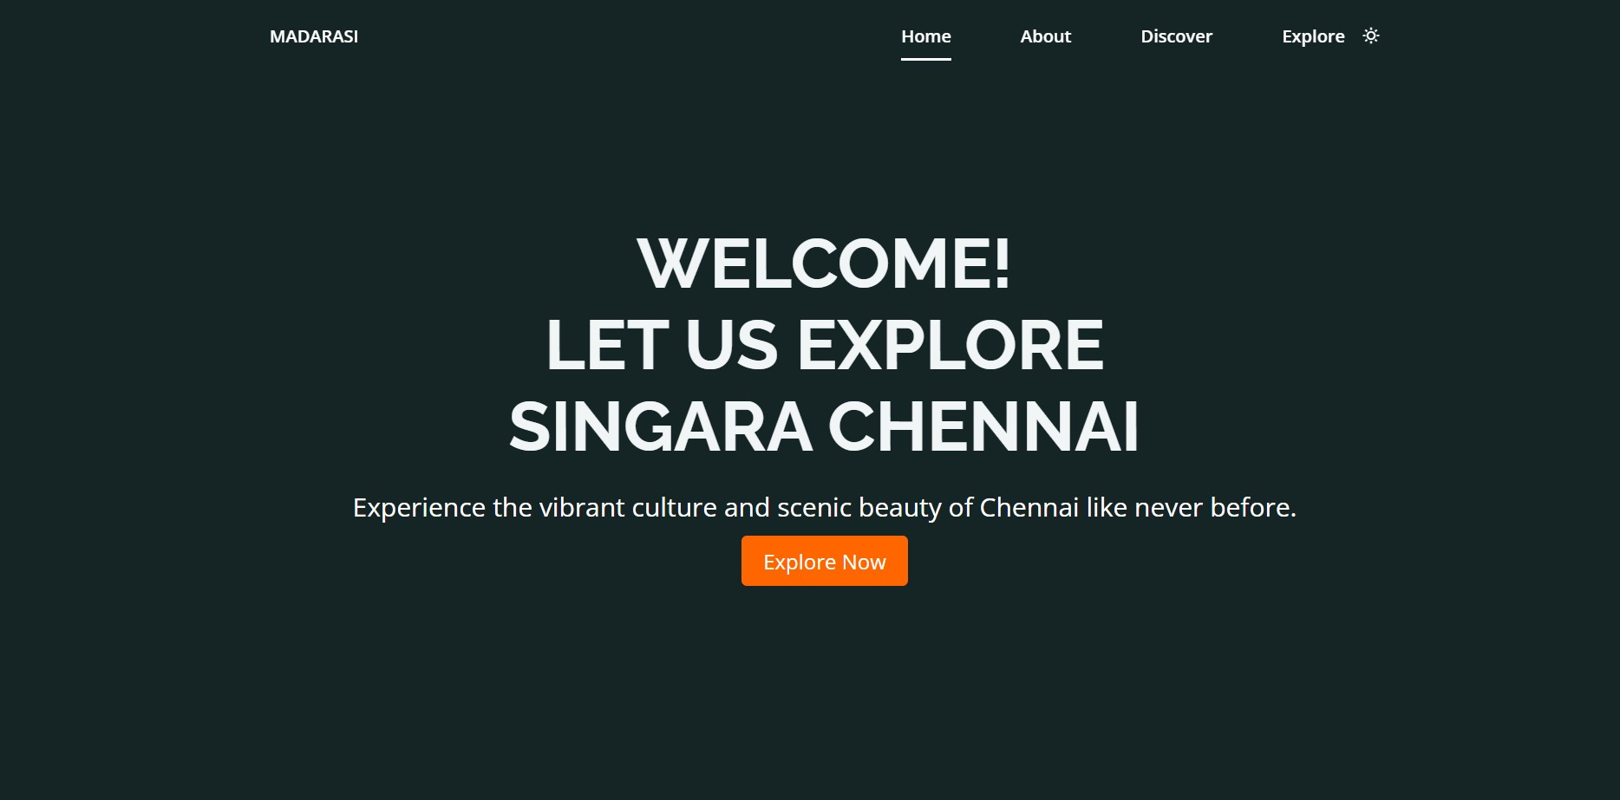

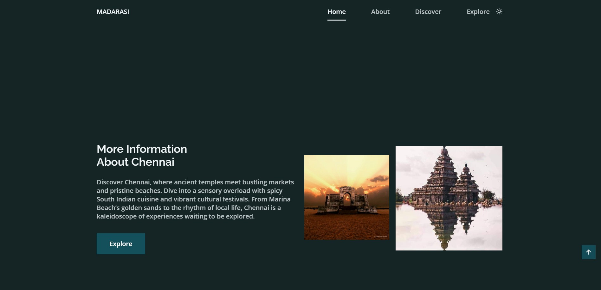

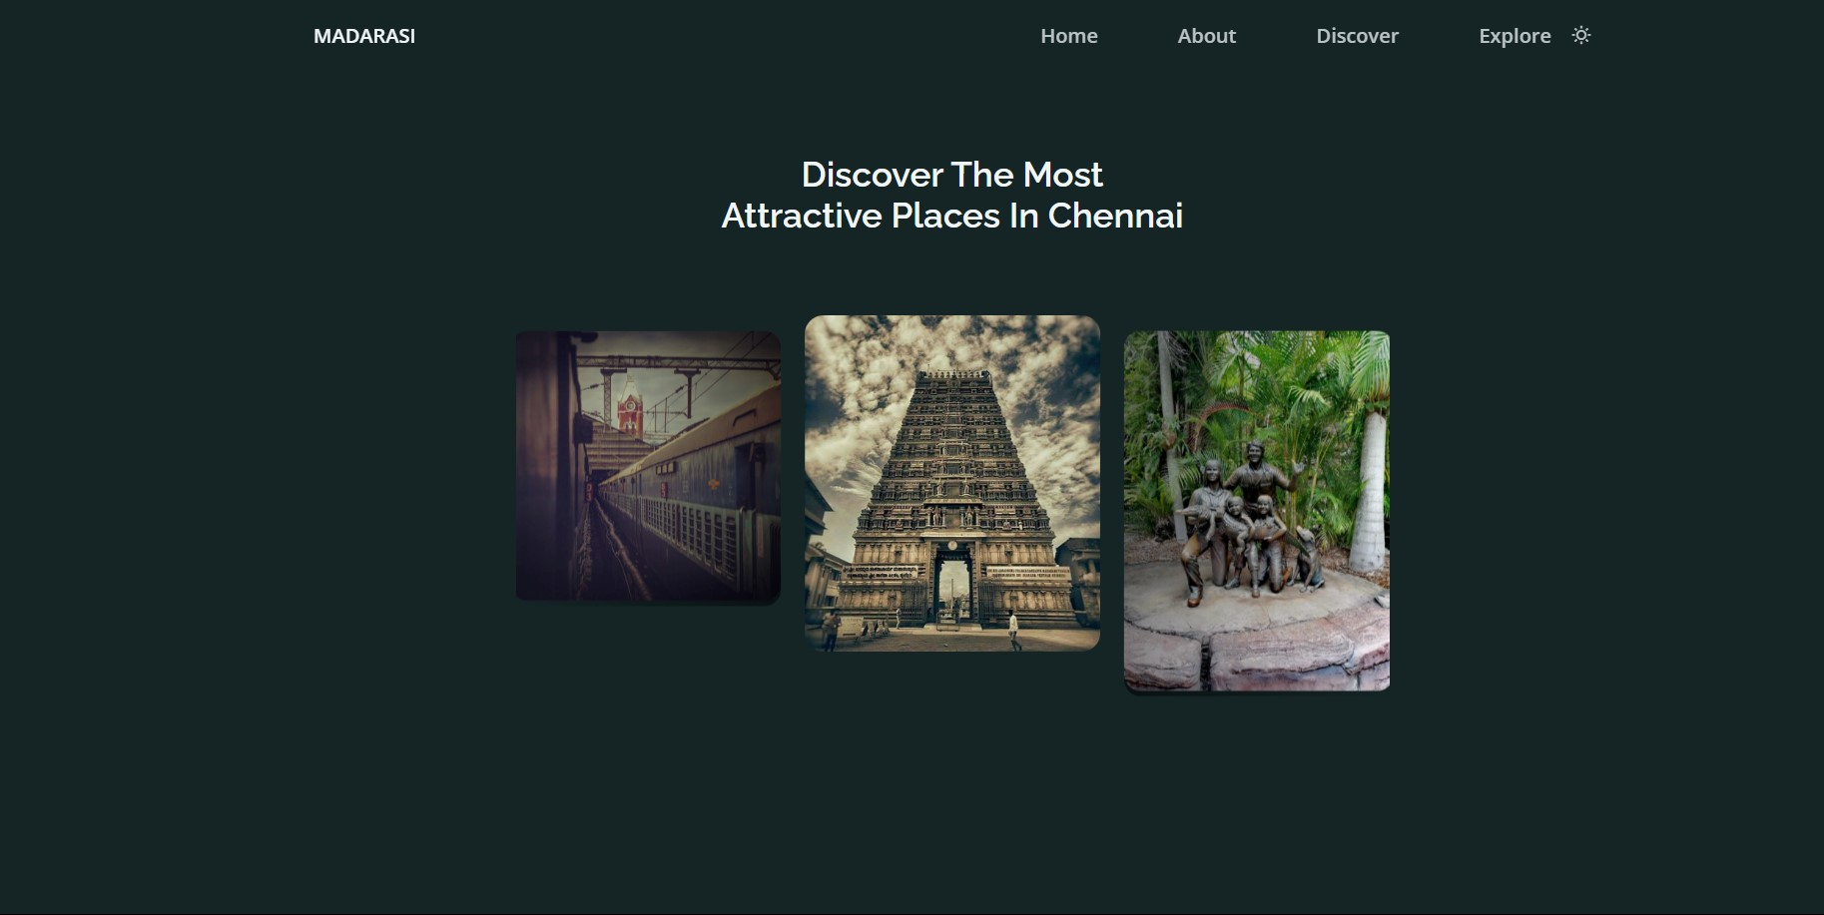

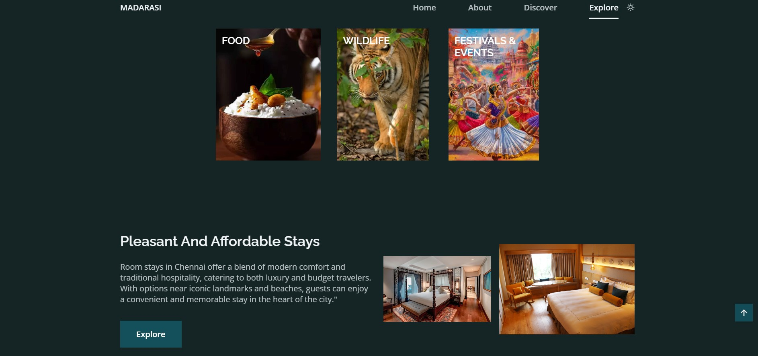

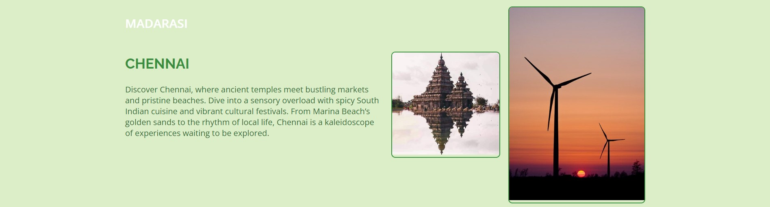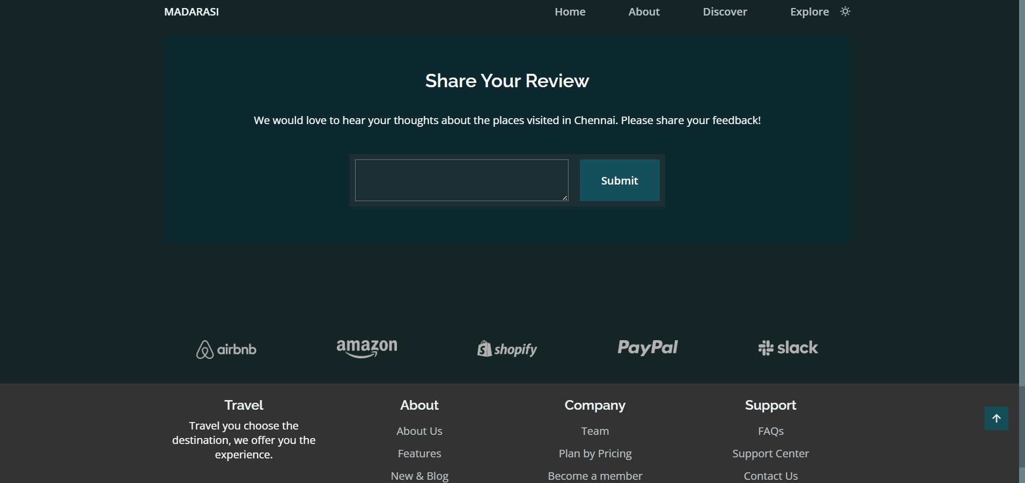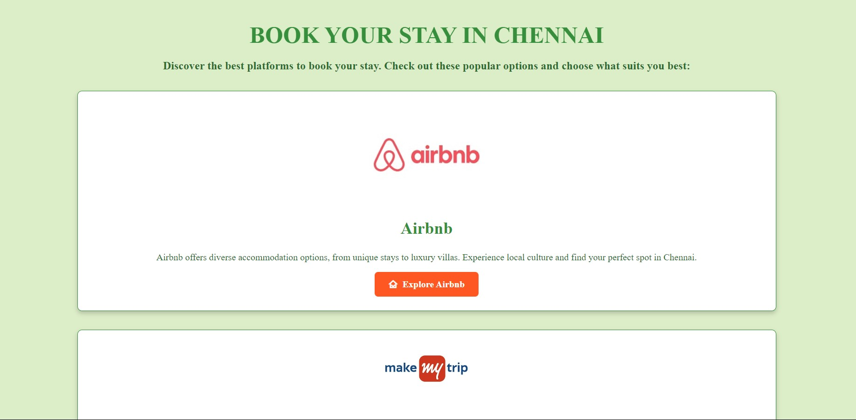

#### CONCLUSION

In conclusion, the Chennai Tourism Guidance and Hotel Booking Reviews application effectively serves as a comprehensive platform for exploring and planning travel in Chennai. By offering detailed information on tourist attractions and hotel accommodations, along with user-generated reviews, the application provides valuable resources for both local and international travelers. The use of **responsive design**, **interactive maps**, and **dynamic search and filtering options** enhances the overall user experience, making it easier for users to find and book suitable options based on their preferences.

The implementation of modern web technologies, including **HTML5**, **CSS3**, **JavaScript**, and **Bootstrap**, ensures a visually appealing and user-friendly interface that adapts seamlessly to various devices. The addition of features like **image carousels** and **review submission** functionality further enriches the site, providing a robust platform for user engagement and interaction.

Looking ahead, there is significant potential for expanding the application’s capabilities through the integration of advanced technologies and additional features. Future enhancements could include personalized recommendations powered by **artificial intelligence**, real-time booking functionalities, multilingual support, and more extensive user-generated content. These developments will not only improve the service but also ensure that the application remains a valuable tool for travelers seeking to explore Chennai’s vibrant tourism scene.

#### REFERENCES

1. **W3C. (2014). *HTML5 Specification*. Retrieved from** [**https://www.w3.org/TR/html5/**](https://www.w3.org/TR/html5/)
2. **W3C. (2011). *CSS3 Specification*. Retrieved from** [**https://www.w3.org/TR/css3-roadmap/**](https://www.w3.org/TR/css3-roadmap/)

##### 3. Marcotte, E. (2010). *Responsive Web Design*. A List Apart. Retrieved from https://alistapart.com/article/responsive-web-design/ 4. Google Developers. (2020). *Responsive Web Design Basics*. Retrieved from https://web.dev/responsive-web-design-basics/

**5. Xu, J., & Li, G. (2020). *Artificial Intelligence in the Tourism Industry: Current***

***Applications and Future Directions*. Journal of Tourism Research, 12(3), 125-139.**

**33**